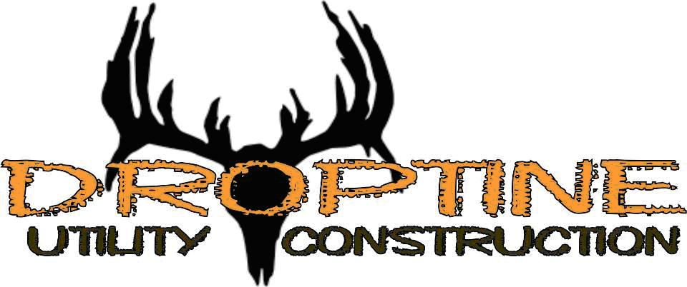

Limited Warranty Letter

Droptine Utility Construction shall warrant all work against defects in materials and workmanship for a period of (10) years, from date of substantial completion. Droptine Utility Construction shall within a reasonable time after receipt of written notice thereof, repair defects in materials or workmanship which may develop during said one (10) year period and any damage to work caused by such defects or the repairing of same, without cost to the client.
Standard Cement warrants its products to be free of manufacturing defects and that they will meet Standard Cements current published physical properties, when applied in accordance with Standard Cement directions and tested in accordance with Standard Cement standards. Droptine Utility Construction must receive written notice of any defects within thirty (30) days of the discovery of the defect and within (10) years of the original installation date listed by the Certified Standard Cement Applicator.
This warranty does not include exposure to conditions other than as designed and represented as suitable with Standard Cement’s written documentation, nor failure due to physical damage, mechanical abuse, chemical abuse, Acts of God, improper maintenance or care by owner. NO ACTION AGAINST DROPTINE UTILITY CONSTRUCTION MAY BE COMMENCED MORE THAN (10) YEARS AFTER THE ORIGINAL INSTALLATION DATE.
Installation Date: 10/10/2024 Project Name: Grace Valley Ranch Phase 2

Manhole Numbers
MH A-6 | MH A-7 | MH A-8 | MH A-9 | MH A-10 | MH A-11
MH E-6 | MH E-7 | MH E-8 | MH E-9 | MH E-10 | MH E-11
MH E-12 | MH E-13 | MH E-14 | MH J-1 | MH I-1 | MH H-1
MH H-2 | MH H-4 | MH H-5 | MH H-6 | MH H-7

Raymond Davila
Owner
Droptine Utility Construction

