**Addendum 2**

**lennar homes of texas land and construction, ltd. on behalf of guadalupe county mud nO 14**

**Parkside Unit 4**

This Addendum No. 2 shall provide clarification and/or modification to the existing Bid Documents, Plans, and Specifications representing Lennar Homes of Texas Land and Construction LTD.

**Clarifications:**

1. Any excess materials will be stockpiled within the future Parkside units. The excess can be placed without requiring travelling on public roads.
2. TxDOT Plans that include a traffic signal are necessary with this unit’s development. These have been provided.

**Additional Items:**

1. SW3P & Sitework

* *Line Item 1-4:* Separated these into reimbursable vs. non-reimbursable items.
* *Line Item 5-*7: Provided instructions for the required fill in Unit 4. This can come from U5 excess, utility spoils, and offsite hauling.
* *Line Item 15:* Added a temporary sedimentation basin.

1. Water Improvements.

* *Line Item 16:* 2” SCH 80 PVC is required for long lead service lines. This has been added to the bid form.

**Schedule:**

* Monday, January 6, 2025 @ 5 PM: Deadline for Questions
* Wednesday, January 8, 2025 @ 2 PM: Deadline for submitting bids and Bid Opening Meeting

In an effort to give everyone time to make adjustments to the bids based on the collected questions, Bids are now due to Riess Doerr by email on or before Wednesday, January 8, 2025 at 2:00 PM.



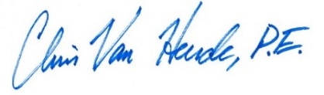

12/27/2024